Pumpkin Pie Play Dough
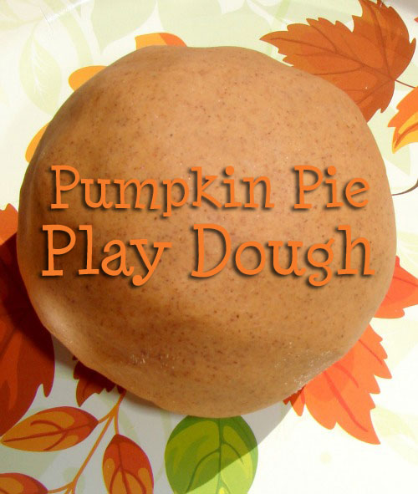

This play dough smells so incredibly yummy. It smells just like pumpkin pie. I

Pumpkin Pie Play Dough Recipe
1 cup flour
1/2 cup salt
1 cup water
2 tbsp oil
2 tbsp cream of tartar
1/3 of the jar of pumpkin pie spice (the tiny jar)
maple extract
vanilla extract
food coloring
Combine the dry ingredients and the oil. Slowly add the water. Add a few dashes of each of the extracts and a few drops of red and yellow food coloring. Cook over medium heat, stirring until stiff.
As it mixes you can see if you'll need more food dye. We tried to be conservative at first, because I didn't want it to be too vibrant. We added a little at a time until we achieved the right color.
Once it's finished cooking, turn out onto wax paper and allow to cooldown.
The pumpkin pie spice was too spicy by itself, for my liking. The extracts make it smell sweeter, just like a pumpkin pie. Sniff the dough. Does it smell too spicy? Add a little bit more extract and knead it all together. If the dough is too sticky, add a little more flour. If it's too dry, add a few drops of water.

